Netter Diagram Answers
- Coronal suture
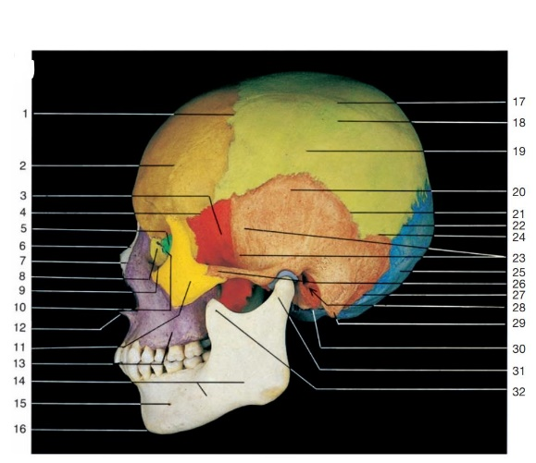
- Frontal bone
- Sphenoidal bone
- Sphenofrontal suture
- Ethmoidal bone
- Nasal bone
- Nasomaxillary suture
- Lacrimal bone
- Lacromaxillary suture
- Ethmoidolacrimal suture
- Zygomatic bone
- Anterior nasal spine
- Maxilla
- Mandible
- Mental foramen
- Mental protuberance
- Superior temporal line
- Inferior temporal line
- Parietal bone
- Temporal bone
- Squamous suture
- Lambdoid suture
- Temporal fossa
- Parietomastoid suture
- Occipital bone
- Zygomatic arch
- Occipitomastoid suture
- External acoustic meatus
- Mastoid process
- Tympanic portion of temporal bone
- Condylar process of mandible
- Coronoid process of mandible

- Frontal bone (brown)
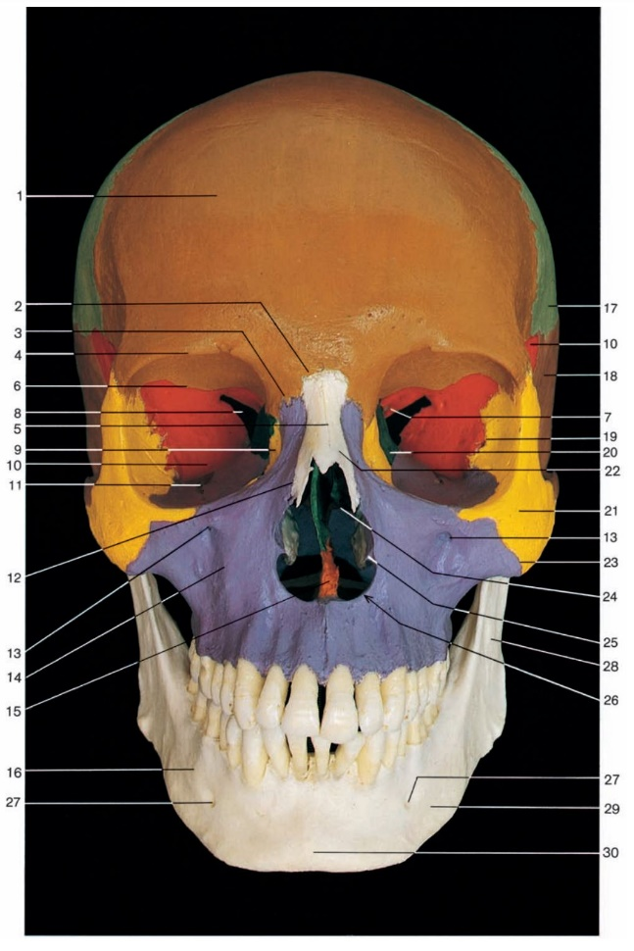
- Frontonasal suture
- Frontomaxillary suture
- Supre-orbital margin
- Internasal suture
- Sphenofrontal suture
- Optic canal in lesser wing of sphenoid bone
- Superior orbital fissure
- Lacrimal bone (yellow)
- Sphenoidal bone (greater wing) (red)
- Inferior orbital fissure
- Nasomaxillary suture
- Infra-orbital foramen
- Maxilla (violet)
- Vomer (orange)
- Body of mandible (white)
- Parietal bone (light green)
- Temporal bone (dark brown)
- Sphenozygomatic suture
- Ethmoidal bone (dark green)
- Zygomatic bone (yellow)
- Nasal bone (white)
- Zygomaticmaxillary suture
- Middle nasal concha
- Inferior nasal concha
- Anterior nasal aperture
- Mental foramen
- Ramus of mandible (white)
- Base of mandible (white)
- Mental protuberance

- Greater wing
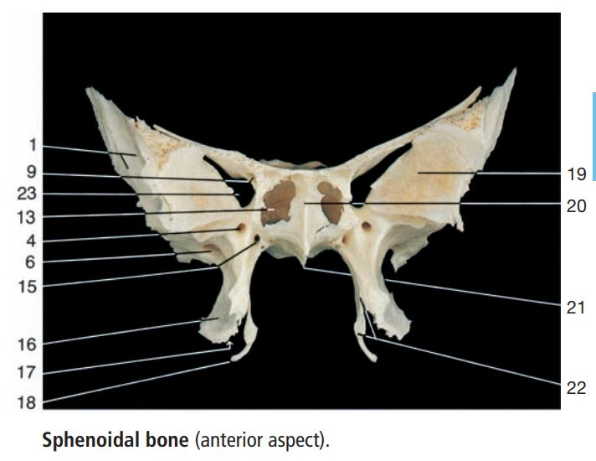
- Lesser wing
- Cerebral or superior surface of greater wing
- Foramen rotundum
- Anterior clinoid process
- Foramen ovale
- Foramen spinosum
- Dorsum sellae
- Optic canal
- Chiasmatic groove
- Sella turcica
- Lingula
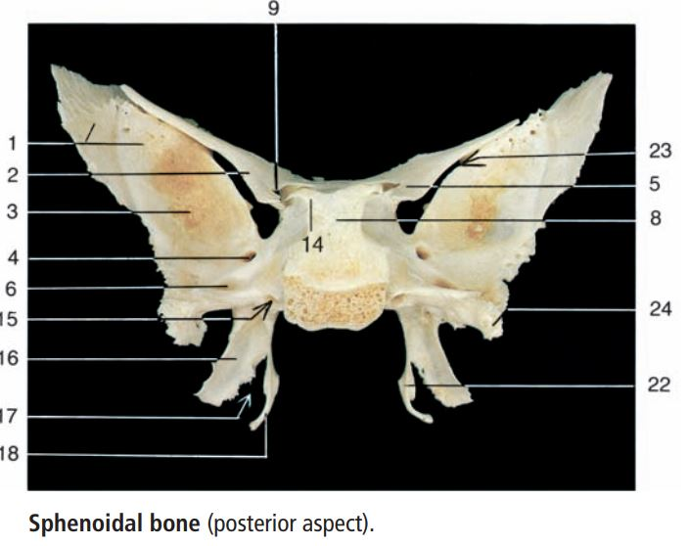
- Opening of sphenoidal sinus
- Posterior clinoid process
- Pterygoid canal
- Lateral pterygoid plate of pterygoid process
- Pterygoid notch
- Pterygoid hamulus
- Orbital surface of greater wing
- Sphenoidal crest
- Sphenoidal rostrum
- Medial pterygoid plate
- Superior orbital fissure
- Spine of sphenoid
- Temporal surface of greater wing
- Infratemporal crest

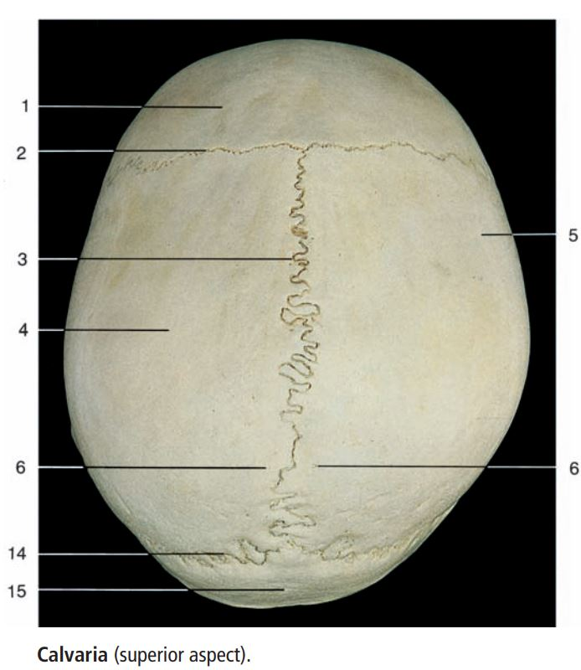
1. Frontal bone
2. Coronal suture
3. Sagittal suture
4. Parietal bone
5. Superior temporal line
6. Parietal foramen
7. Parietal tuber or eminence
8. Sagittal margin
9. Occipital margin
10. Frontal margin
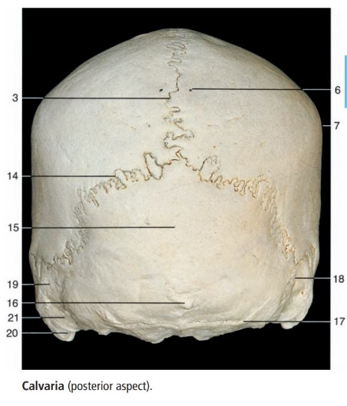
11. Squamous margin
12. Sphenoidal angle
13. Groove for middle meningeal artery
14. Lambdoid suture

